**DBMS ASSIGNMENT 9**

**CLASS: TE B**

**ROLL NO: 322008**

**Problem Statement:** Study of Open Source NOSQL Database: MongoDB (Installation, Basic CRUD operations, Execution)

**Screenshots:**

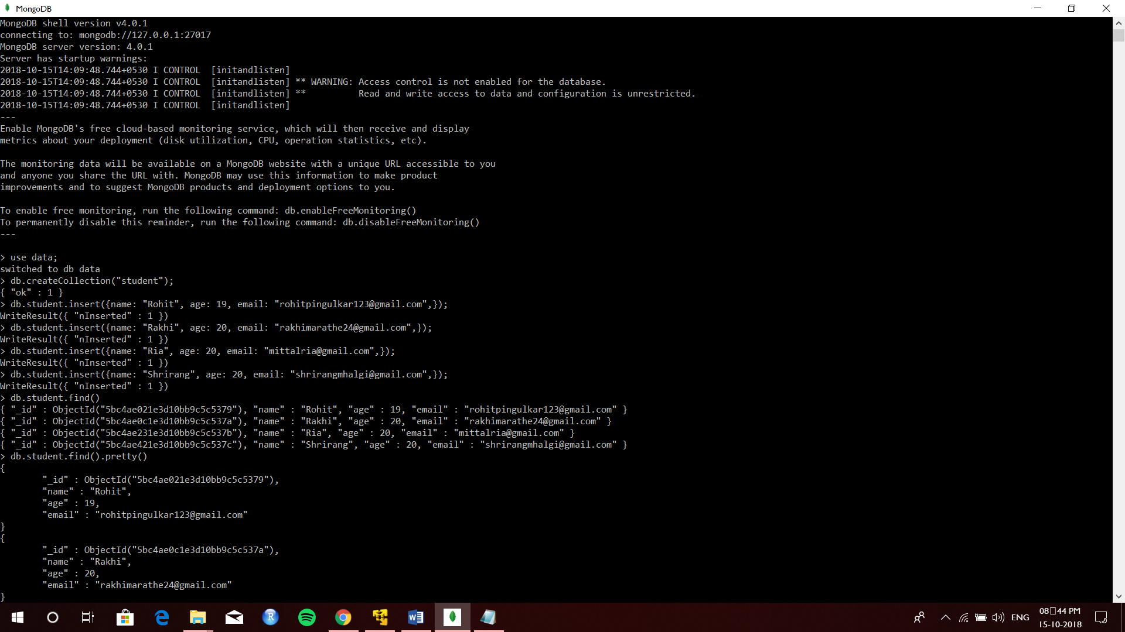

**Queries:**

Use data;

Db.createCollection(“student”);

Db.student.insert({name : “Rohit”, age : 19, email : “rohitpingulkar123@gmail.com”});

Db.student.insert({name : “Rakhi”, age : 20, email : “rakhimarathe24@gmail.com”});

Db.student.insert({name : “Ria”, age : 20, email : “mittalria0809@gmail.com”});

Db.student.insert({name : “Shrirang”, age : 20, email : “shrirangmhalgi@gmail.com”});

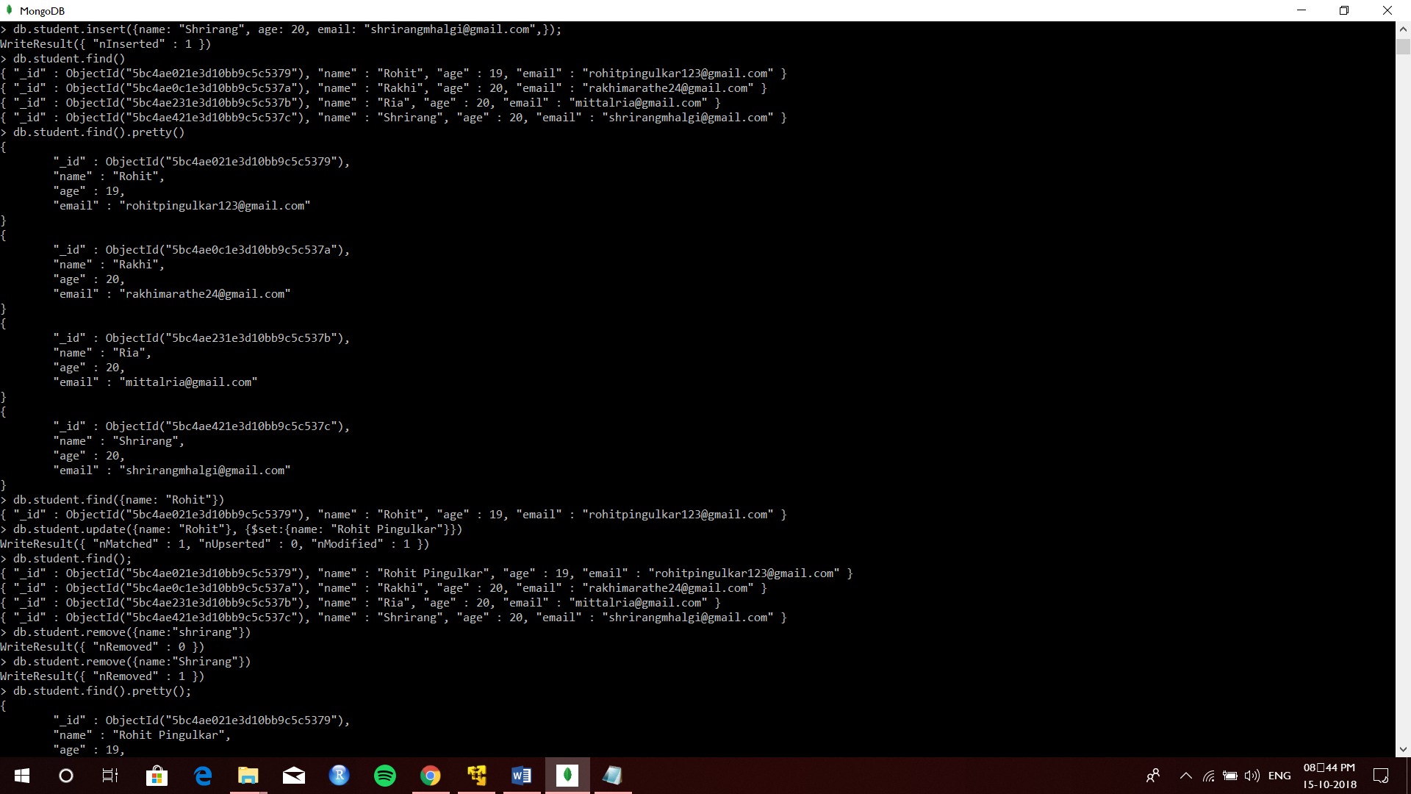

**Queries:**

Db.student.find({name : “Rohit”});

Db.student.update({name : “Rohit”}, {$set{name : “Rohit Pingulkar”}});

Db.student.find();

Db.student.remove({name : “Shrrang”});

Db.student.find().pretty();

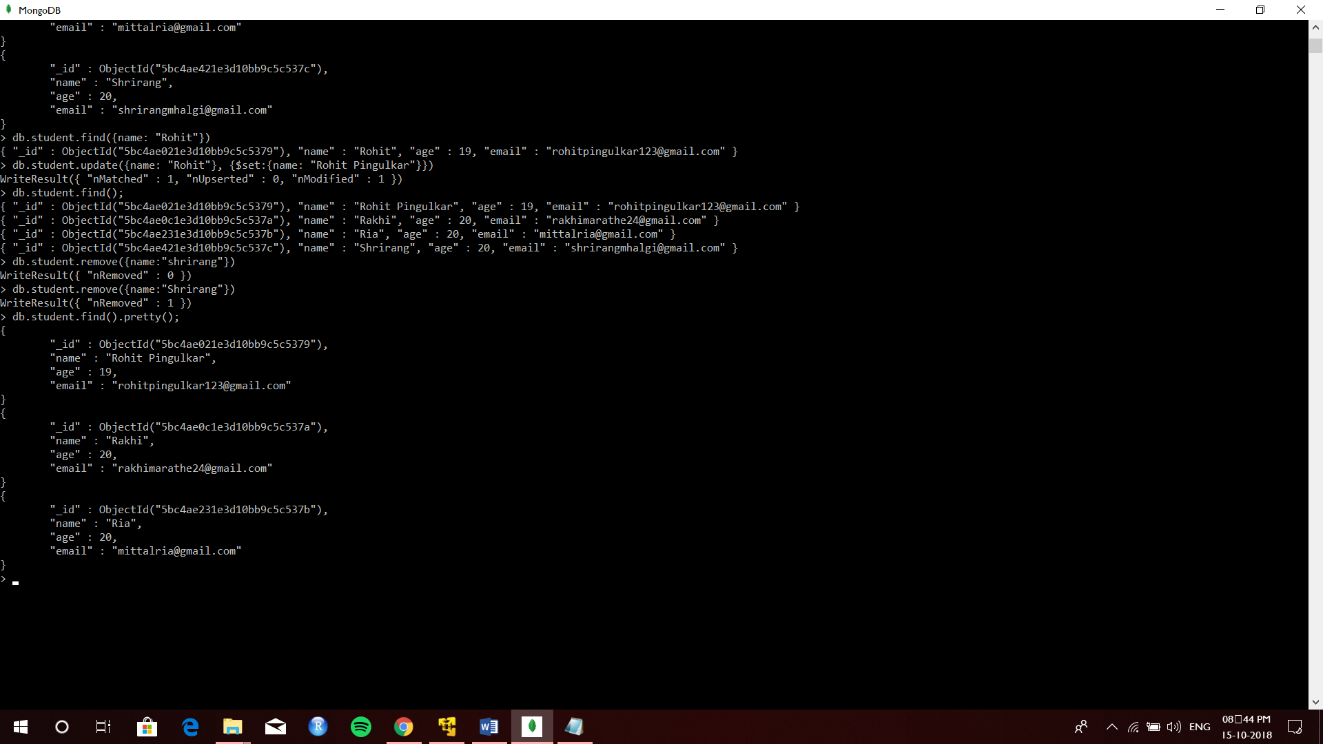

**Conclusion:** MongoDB (Installation, Basic CRUD operations, Execution) were successfully implemented.